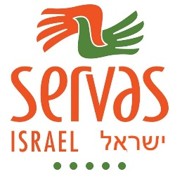
Picnic to celebrate International Peace Day on Saturday 09/24/2016
30 Servas friends, including families and new members, participated in Servas Israel picnic in the Sculptures Trail in Tzora-Hanasi Forest, on Saturday, 09.24.2016, 10:00 to 15:00.
We celebrated International Peace Day by reading poems, parables and stories, discussing the meaning of peace and friendship.
Also we wished each other Best wishes for the Jewish New year, coming on 2 October.
We created sculptures with natural materials, in small groups, and named them by names: the Gate to peace, the Road to peace, the Camel …..
The children among us chose the winners, after their own creation, of course – the Camel, the Gate to Peace.
We ended the day with Servas Get-together meal, and friendly talks over the meal.
Thanks to Meir and Lesley who initiated and planned this meeting.
Thanks to Eli and Shula who brought their family and Francicso from Mexico (who is currently participating in SYLE in Israel)
Best regards, See you next meeting
Servas Israel
